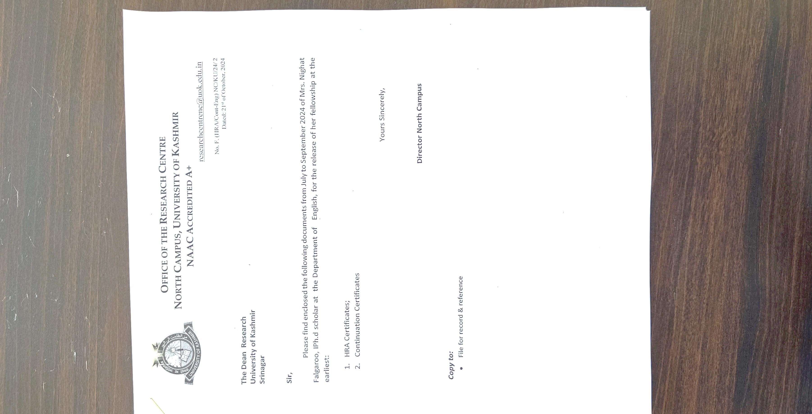

NO.F.(HRA/Cont-Eng) NC/KU/24/2

Dated:24-10-2024

**The Dean Research**

**University of Kashmir**

**Srinagar**

**Sir**,

Please find enclosed the following documents for October 2023 of Mr Adil Hussain, IPh.D scholar at the Department of English, for the release of his fellowship at the earliest:

1. HRA Certificates;
2. Continuation Certificates

Yours sincerely,

**Director North Campus**

**Copy to:**

* File for record and reference